**CSS Box Model**

The **CSS box model** is the fundamental structure used by browsers to render web elements on a page. It defines how the content of an element is surrounded by padding, borders, and margins. Understanding the box model is essential for layout design and spacing in web development.

The box model consists of the following components:

1. **Content**: This is where the actual content (text, images, etc.) of the element is placed.
2. **Padding**: The space between the content and the element's border. Padding increases the size of the box without affecting its outside elements.
3. **Border**: A line that wraps around the padding and content, separating the padding from the margin.
4. **Margin**: The space between the border of an element and surrounding elements. Margins are used to create spacing outside of the element's box.

**Visual Representation of the Box Model**

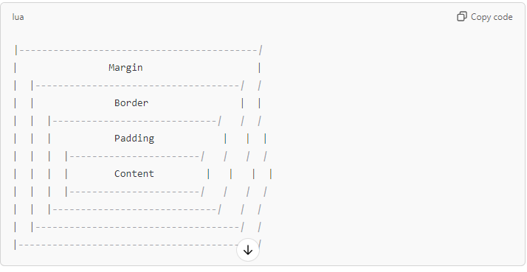

### Example HTML Layout Using the Box Model

html

Copy code

<!DOCTYPE html>

<html lang="en">

<head>

<meta charset="UTF-8">

<meta name="viewport" content="width=device-width, initial-scale=1.0">

<title>Box Model Example</title>

<style>

.box {

width: 200px;

height: 150px;

background-color: lightblue;

padding: 20px;

border: 5px solid black;

margin: 30px;

}

.container {

border: 2px dashed gray;

padding: 10px;

}

.box-small-padding {

padding: 10px;

}

.box-large-margin {

margin: 50px;

}

.box-thick-border {

border: 10px solid red;

}

</style>

</head>

<body>

<div class="container">

<h1>CSS Box Model Example</h1>

<div class="box">

Default Box

</div>

<div class="box box-small-padding">

Small Padding (10px)

</div>

<div class="box box-large-margin">

Large Margin (50px)

</div>

<div class="box box-thick-border">

Thick Border (10px)

</div>

</div>

</body>

</html>

### Explanation of the Example:

1. **Default Box**: This element has 20px padding, a 5px black border, and a 30px margin.
2. **Small Padding Box**: This box reduces the padding to 10px, making the content area larger.
3. **Large Margin Box**: This box increases the margin to 50px, creating more space between this box and the surrounding elements.
4. **Thick Border Box**: This box has a thicker border (10px), reducing the content area inside but making the element more prominent.

### Visual Changes by Adjusting Padding, Margin, and Border:

1. **Changing Padding**: Increasing padding creates more space between the content and the border, making the element's box larger without affecting other elements.
2. **Changing Margin**: Increasing the margin increases the space between the element and its neighbors, creating larger gaps between elements on the page.
3. **Changing Border**: A thicker border shrinks the visible content area inside the element, but the overall box (including border and margin) takes up more space.